Brandy Stark (PhD)
Professor of Humanities and Religious Studies, St. Petersburg College
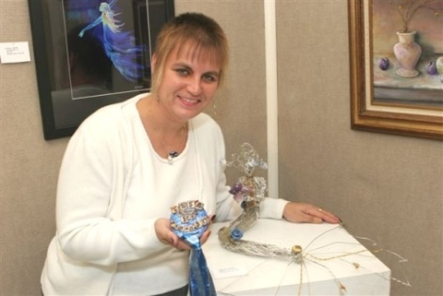
​Artist Statement

Religions hold a beautiful understanding of the world: We are interconnected to nature and to each other. In nature we find the underlying communal whole, the essence that ties us all together. In community we are to learn to work together and to encourage the bettering of self, community, and the world. I integrate these ideas into my art by incorporating found objects into wire works created by twisting and sewing individual wire pieces together. It is a reminder that everyone and everything has a purpose; the individual is essential to the work and yet becomes absorbed by it. It is my hope that my art will remind the viewer to analyze the relationship they hold with the world around them and to fully engage with the incredible nature of what we experience daily.

See also: www.bstarkart.com/Main.html
Email: stark_brandy@hotmail.com
Phone: 727/821-5759

